
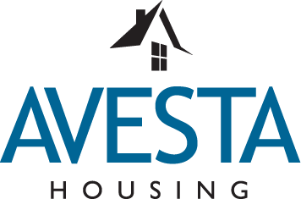

For Immediate Release Contact: Rod Harmon, Communications Manager
March 16, 2025 cell: 207-272-3986; email: rharmon@avestahousing.org

Avesta Housing names new director of development

PORTLAND, Maine — Avesta Housing, the largest nonprofit affordable housing provider in New England, has hired John Egan to be its new director of development.

In his new position, John leads Avesta’s real estate development team in developing and preserving affordable rental housing in Maine and New Hampshire. He has nearly four decades of community development experience in Maine and Alaska as a developer, lender, investor and owner, and has served on numerous boards of community non-profit organizations.

Prior to joining Avesta, John served on the program team at the Genesis Community Loan Fund for five years, where he provided technical guidance and facilitation on the development process as well as the preservation of rural affordable rental properties financed by USDA. John also worked for 20 years at CEI as a housing developer and lender, and as chief investment officer leading the lending and investment team.

“I am confident that John’s deep real estate development experience, combined with his clear commitment to Avesta’s mission, will result in our ability to expand our housing development pipeline and help meet the acute housing shortage in northern New England,” said Avesta Housing President & CEO Jennifer Hawkins.

PHOTO: John Egan
# # #

About Avesta Housing
Avesta Housing is a nonprofit affordable housing provider with more than 50 years of experience as a leader in affordable housing development and property management in Maine and New Hampshire. The organization is headquartered in Portland, Maine, and operates more than 100 affordable properties, more than 3,000 apartments and two assisted living facilities, providing safe, affordable homes for almost 5,000 people every day. An additional 1,100 new homes are in the development pipeline. Avesta was named a Best Place to Work in Maine in 2024 and 2025. Avesta’s mission is to improve lives and strengthen communities by promoting and providing quality affordable homes for people in need. www.AvestaHousing.org

